Activity 1: Multimeter
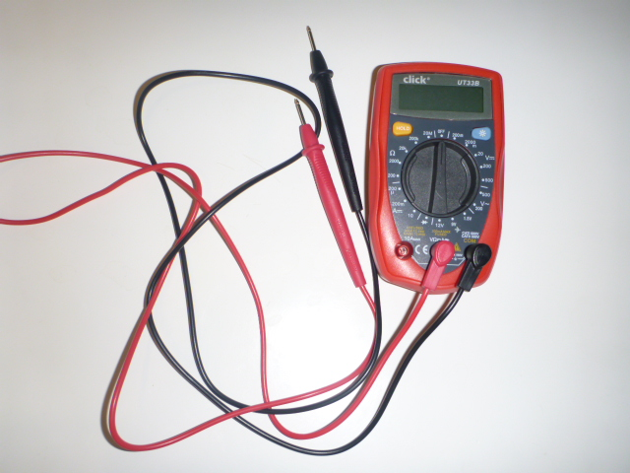

Where is the science in this?

Activity 2: Breadboard
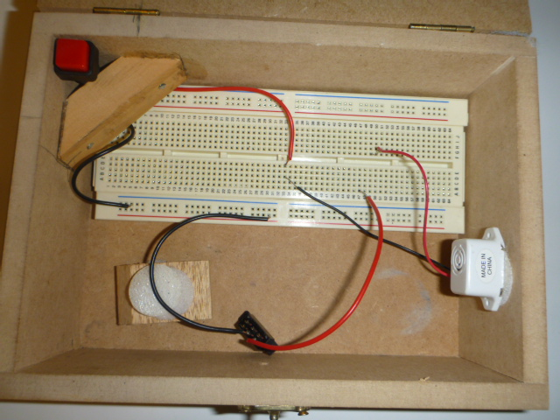
Where is the technology in this?

Activity 3: Broken Toy
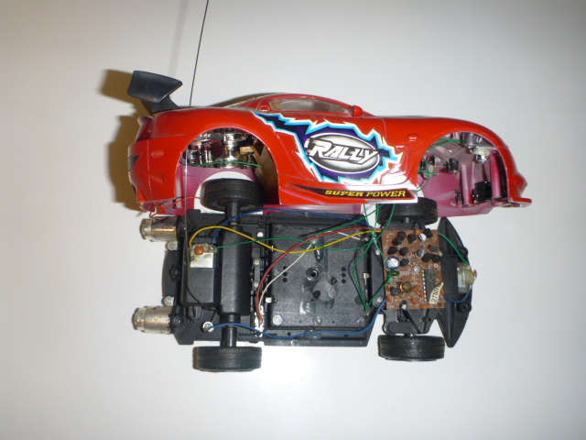
Where is the engineering in this?

Activity 4: Evil Teddy
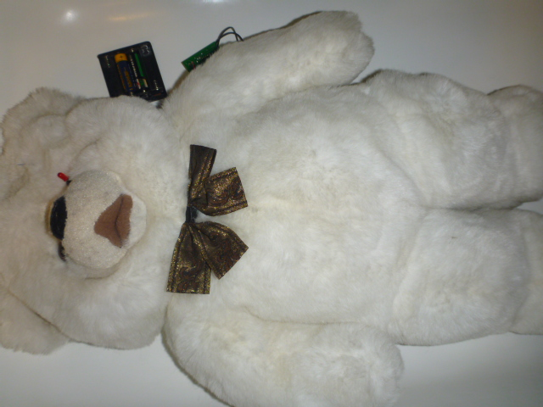
Where is the mathematics in this?

Activity 5: Night Light
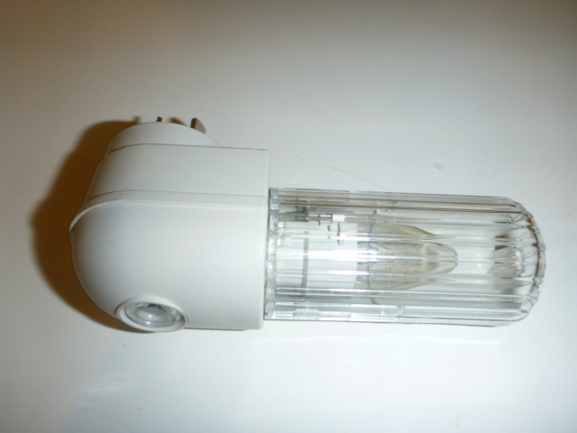
Where is the science in this?

Activity 6: It takes all sorts
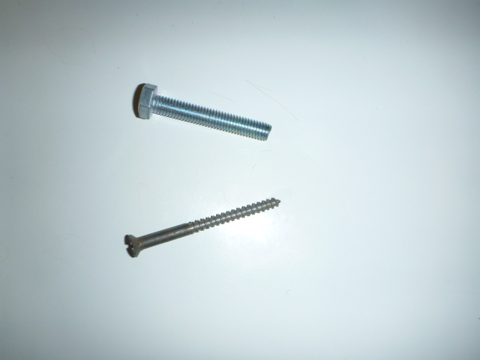
Where is the technology in this?

Activity 7: Vacuum forming
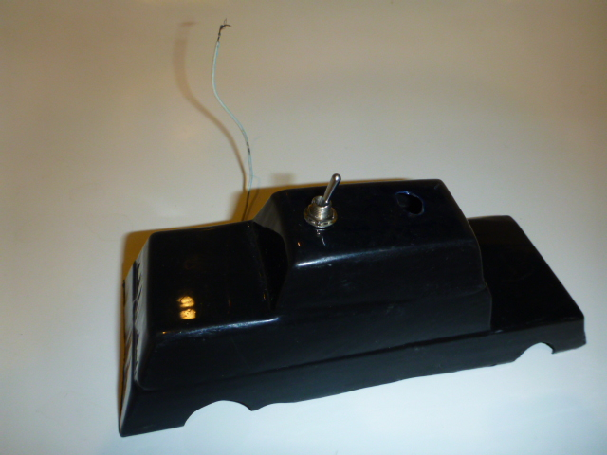
Where is the engineering in this?

Activity 8: 1992 Technology
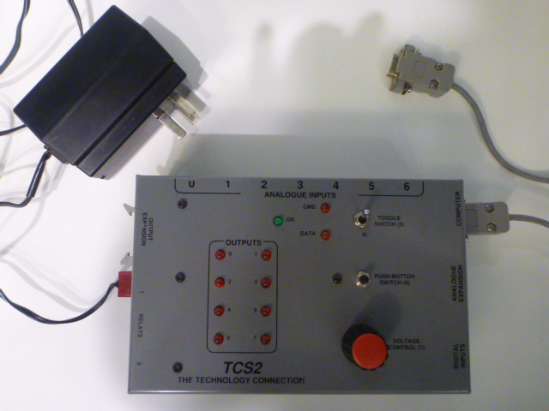
Where is the mathematics in this?

Activity 9: Kit
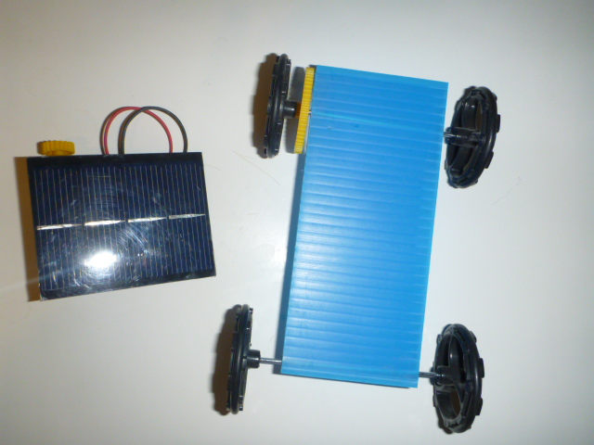
Where is the science in this?

Activity 10:
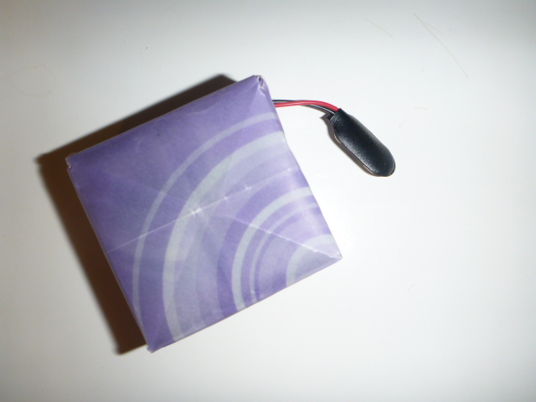
Where is the technology in this?

Activity 11: Helicopter Flight
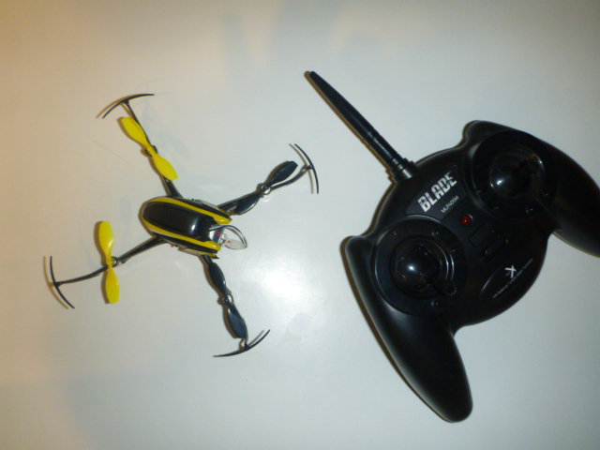
Where are the science, technology, engineering and mathematics in this?
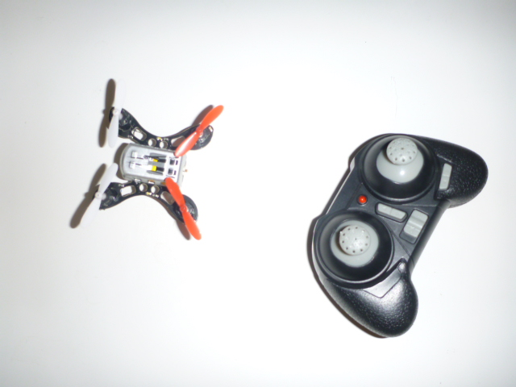

Your name | Email

